Organisational Profile

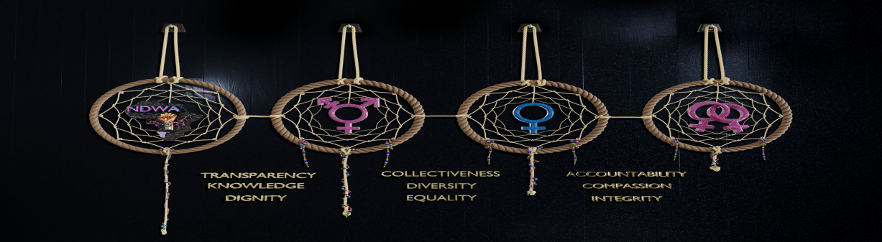

Organisational Information
Organisational Name | Namibia Diverse Women’s Association
Acronym | NDWA
Email | namibiadiversewomen@gmail.com
Address | 11 Behring Street Windhoek West
City | Windhoek
Country | Namibia
Postal Address | P. O. Box 7110 Katutura
 | Windhoek- Namibia

Contact Persons
Designation | National Coordinator
Name | Justine Hamupolo
Email | namibiadiversewomen@gmail.com
Contact Number | +264 81 424 0198
Designation | Strategic Coordinator
Name | Linda RM Baumann
Email | lbaumann82@gmail.com
Contact Number | +264 81 252 8259

Establishment /Legal Status
Established | 2016
Target Group | Women , Girls and Trans Diverse Persons
Primary Target Group | Lesbian, Bisexual, WSW, Trans Women, Gender Non-Conforming (GNC) persons, Queer and others

Geographical Coverage
South Namibia- Karas & Hardap Region | Towns- Keetmanshoop, Karasburg, Luderitz, Mariental, Aranos and Rehoboth
Northern Namibia | Towns- Okahandja, Otjiwarongo, Tsumeb, Oshakati
West Namibia | Towns- Swakopmund, Walvis Bay, Omaruru, Khorixas
Central Namibia | Towns- Windhoek, Katutura and Khomasdal
Eastern Namibia | Town- Gobabis

